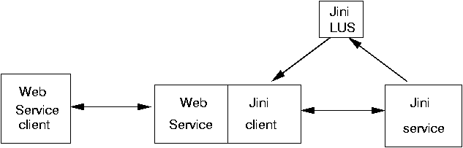

Production: Please make the following changes to this image.

LUS → Lookup Service
Jini client → Jini Client
Jini service → Jini Service
Java Web Service client → Java Web Service Client

