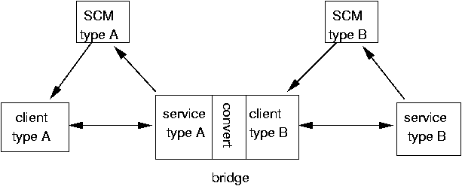

Production: Please make the following changes to this image.

SCM type A → SCM Type A
SCM type B → SCM Type B
client type A → Client Type A
service type A → Service Type A
convert → Convert
bridge → Bridge
client type B → Client Type B
service type B → Service Type B

