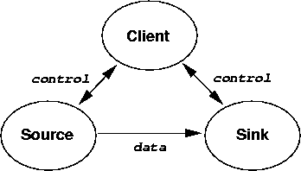

Production: Please make the following changes.

control → Control (x2)
data → Data

